Groundbreaking for the Forest Bioproducts Research Institute (FBRI) new Office Complex
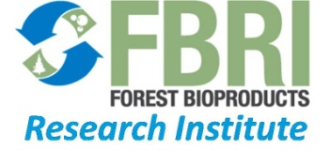
On May 3rd, University of Maine President Robert Kennedy, Maine Technology Institute President Betsy Biemann, and Pingree Associates President Steve Schley broke ground for the 3300 sq. ft. office complex to be added to Jenness Hall. Joining them were Professors Hemant Pendse and Darrell Donahue along with Paige Case, an undergraduate student in the Department of Chemical and Biological Engineering. The new complex will serve as a meeting place where visiting researchers, industrial partners, and FBRI technical staff will collaborate to develop innovative processes and the next generation of forest bio-products. These offices will house as many as 40 people focused on research, as well as training space that includes state-of-the-art video teleconferencing capabilities to educate and collaborate with FBRI partners from around the globe. The new complex will provide space for operations for the FBRI research enterprise as well as for administrative and technical staff. The renovation is supported by a grant from the Maine Technology Asset Fund (MTAF).

“In a struggling Maine economy, the Forest Bioproducts Research Institute has found a way to help. The FBRI has made it its mission to find innovative and new uses for sustainably harvested wood from Maine forests. The work being done at FBRI could markedly change the way forest resources are looked at and utilized” said Hemant Pendse, the founding Director of FBRI. In order to reduce the dependency on fossil fuels, FBRI is using cutting-edge technology to create new bio-products, such as transportation fuels, wood-based chemicals, and consumer products in ways that will leave a smaller ecological footprint. FBRI is helping to get these bio-products to markets as quickly as possible by providing a way for businesses to see and to demonstrate the technology first hand in the FBRI laboratories in Jenness Hall.

Class 2011 Chemical Engineering graduates Paige Case and Abbey Siegfried have been working on novel technologies for making novel bioproducts like biofuels (green gasoline, diesel or jet fuel) from wood and separating chemicals (e.g. acetic acid) from wood extracts. Graduate student Alex Demers is working on making carbon nanofibers from lignin, a waste product from pulping. Professor Pendse highlighted Paige, Abbey and Alex at the ground-breaking ceremony as the Face of "Bioproducts Research” on fuels, chemicals, and advanced materials from forest biomass.

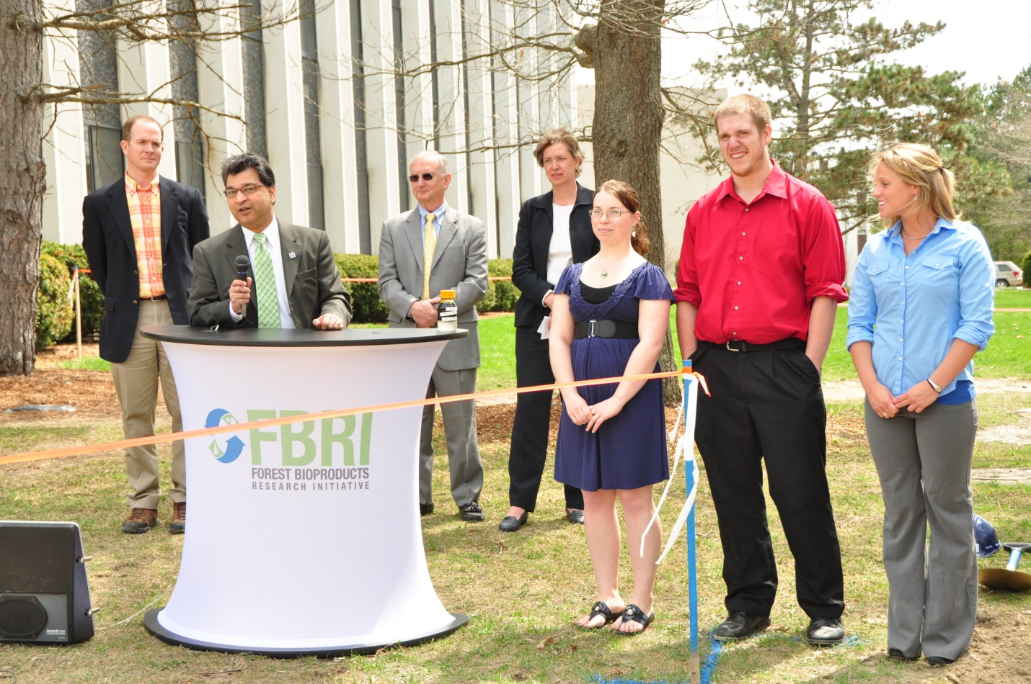
(From left to right: Steve Schley, Hemant Pendse, Robert Kennedy, Betsy Biemann, Paige Case, Alex Demers, and Abbey Siegfried)

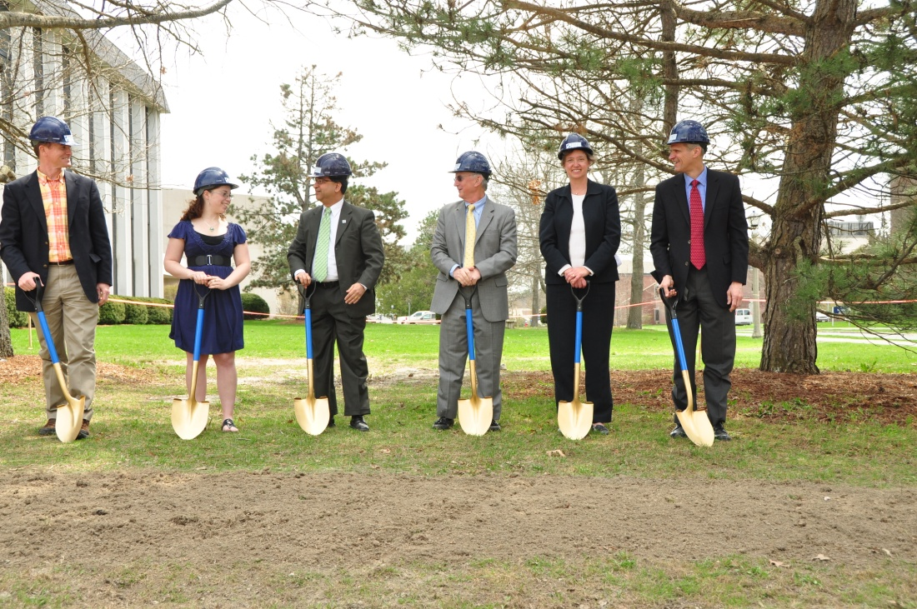

(From left to right: Steve Schley, Paige case, Hemant Pendse, Robert Kennedy, Betsy Biemann, Darrell Donahue)

