GROUND BREAKING ON Tues. May 3rd, 2011

Contact: Prof. Hemant Pendse, Director FBRI and Chair, Chemical and Biological Engineering Department

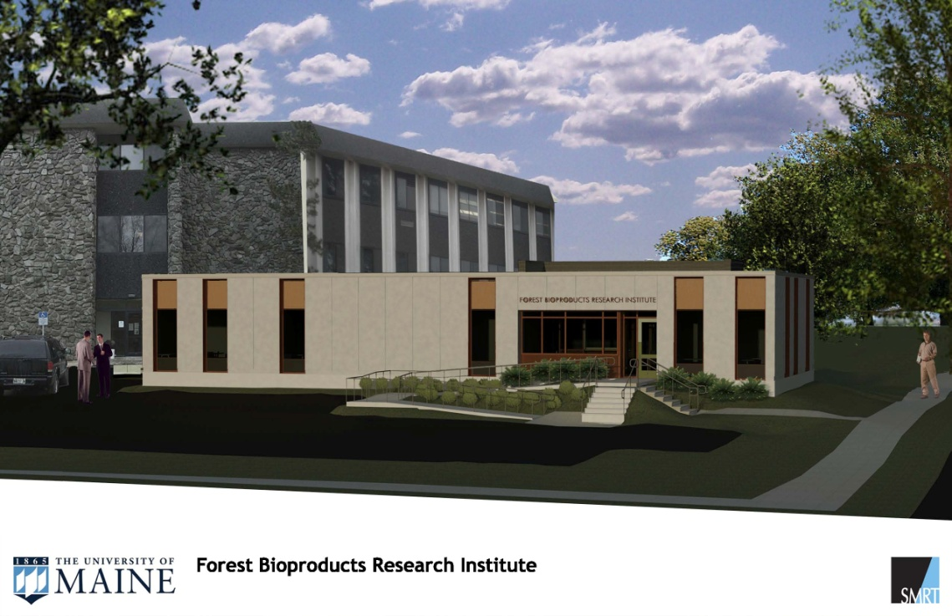

On-campus collaboration space will be added to Jenness Hall

The over 3300 sq ft office complex will provide for the collaboration and training for up to 40 people focused on research examining the issues involved in developing the next generation of forest bioproducts. The office complex will house the FBRI administrative and technical staffs. There will be nearly 1000 sq ft of dedicated collaborative spaces where FBRI technical staff will work with visiting researchers and industrial partners to develop future bioproducts and associated processes. There will be nearly 600 sq ft of state-of-the-art training space with video teleconferencing capabilities to educate and collaborate with FBRI partners around the globe. This office complex will provide collaborative space for operations for the FBRI research enterprise.

This renovation is supported by a grant from Maine Technology Asset Fund (MTAF).

